Logistic Regression
Logistic Regression is a Supervised Machine Learning Algorithm used for Classification problems.
👉 It predicts categories, not continuous values.
Examples:
- Email → Spam / Not Spam
- Student → Pass / Fail
- Disease → Yes / No
- Loan → Approved / Rejected
So the output is usually 0 or 1.
0 → No / False / Negative
1 → Yes / True / Positive
Sigmoid Function (Heart of Logistic Regression)
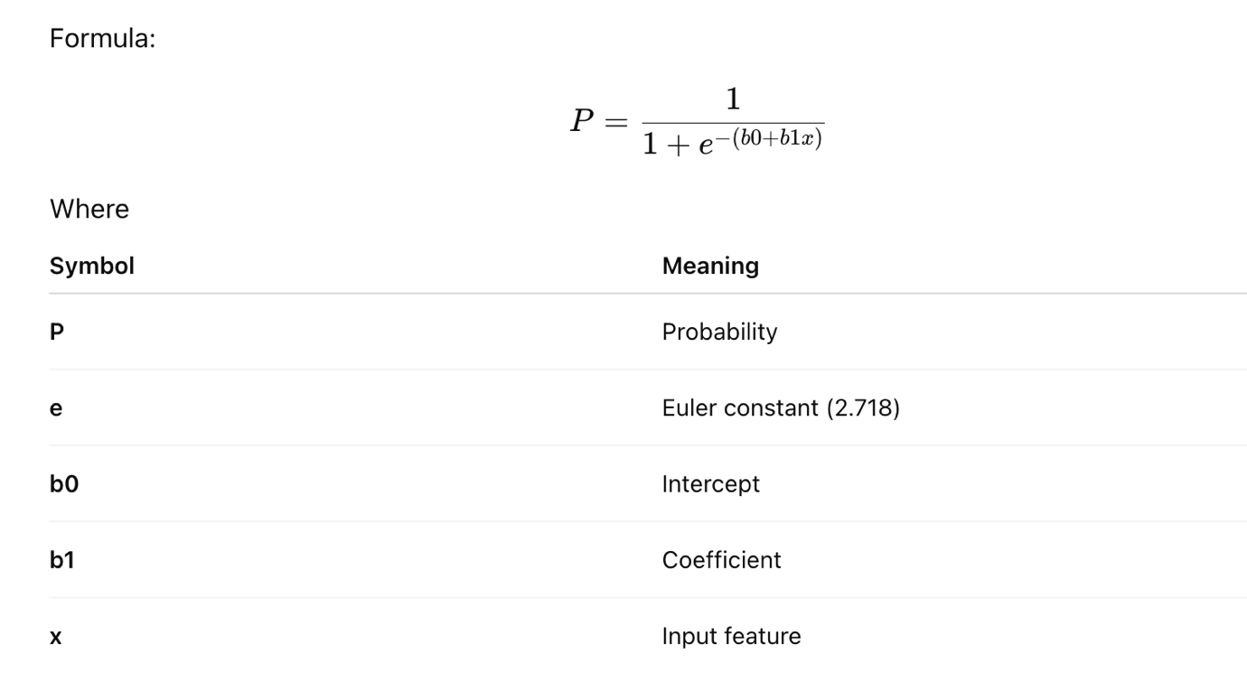
Coefficient tells how much the output changes when input increases.(b1)
Study Hours (x) | Result
1 | Fail
2 | Fail
5 | Pass
6 | Pass
Suppose model learned:
b1 = 1
Every 1 hour increase in study increases chance of passing.
Ex.
salary = 20000 + 5000 × experience
experience called as Coefficient
Intercept (b0)
👉 Starting value when input = 0
salary = 20000 + 5000 × experience
If experience = 0
salary = 20000
So 20000 is intercept.

